**LOVELY PROFESSIONAL UNIVERSITY**



**AI GAME CHESS**

**PYTHON PROGRAMMING LANGUAGE**

**INT 404**

**SUBMITTED BY:**

**KADIYALA NAGA JYOTHI(K18BY,05)**

**KAJAL SINGH(K18BY,06)**

**RAHUL RANJAN(K18BY,07)**

**RAUSHAN RAJ(K18BY,34)**

**AMAN KUMAR(K18BY,08)**

**School of Computer Science and Engineering**

Lovely Professional University

Phagwara, Punjab (India)

OBJECTIVE

Who does not love gaming? It is a activity that someone do to release boredom. Game is fun and can train our brain to think how to solve a problem, especially board games. Chess is also comes under in board games.

Nowadays, chess is played on the computer. It usually has an AI agent to let player practice the game. The AI has a strategy that will search the best move.

The smarter AI it is, the more enjoyment

we feel on beating the AI. So, how about we make a powerful AI on our game that learn the good strategy itself. It will make the human enjoy the game or make them frustrated. So our team create our own game idea which may be enjoyed by the people.

This project is focused on how we create original chess game idea. The code will be focused on designing the basic class for the game ready to be an input of AI algorithm. We preferred python language to implement it, so we should understand on the flow on how to create the game described in this project.

Chess is a board game that I come up with. It’s a turn based game that is played by two players. The board has 9 x 9 tiles. Each players has 6 pawns on their sides with different colors(black and white).Every players has 5 soldier pawns and 1 king. **The objective of this game is to destroy the opponent’s king or all of enemy’s pawns.** Every pawn has attributes called HP (Health Point), ATK (Attack Point) and step. The HP indicates their ability to function or alive. ATK is an attributes to reduce the enemy by the set amount of ATK point. Step point indicates how many step can a pawn move based on their unique movement. There is also a pawn status which tell whether the pawn has been activated or not. If it’s not activated, it cannot move, attack, or evolve.

Description of Project:

**Soldier**

**Movement**: Soldier can only move forward. The number of steps depend on step point. Can bypass opponent’s pawn.

**HP, ATK, STEP** : Default 3, 1, 1

**Attack target and range :**Same like the movement It can only attack forward depend on step point. The pawn won’t move from the original position.

**Knight**

**Movement**: L shaped in every direction (like in chess version). The number of steps is fixed to 1 (ignore step points). Can bypass opponent’s pawn

**HP, ATK, STEP** : Point attributes (if HP, it will be current HP not the max HP) before evolving into knight is added with these points (0,4,0)

**Attack target and range :**Same like the movement. The pawn won’t move from the original position.

**Evolve**: Cannot evolve

**Rook**

**Movement**: can move forward, backward, left, right (like in chess). The number of steps is based on the step points. Can bypass opponent’s pawn

**HP, ATK, STEP** : Point attributes (if HP, it will be current HP not the max HP) before evolving into knight is added with these points (2,2,0)

**Attack target and range :**Same like the movement. The pawn won’t move from the original position.

**Bishop**

**Movement**: Diagonal move in every direction (like in chess). The number of steps is based on the step points. Can bypass opponent’s pawn

**HP, ATK, STEP** : Point attributes (if HP, it will be current HP not the max HP) before evolving into knight is added with these points (2,1,1)

**Attack target and range :**Same like the movement. The pawn won’t move from the original position.

**Queen**

**Movement**: Diagonal move in every direction and can move forward, backward, left and right (like in chess). The number of steps is based on the step points. Can bypass opponent’s pawn

**HP, ATK, STEP** : Point attributes before (if HP, it will be current HP not the max HP) evolving into knight is added with these points (2,2,0)

**Attack range :**Same like the movement. The pawn won’t move from the original position.

**King**

**Movement**: Cannot move

**HP, ATK, STEP** : Default (15,4,1)

**Attack range and target:**Attack like Queen with one range. The pawn won’t move from the original position.

PICTORIAL FLOW OF PROJECT:

Write rule of game.

Write description of game

Write objective of project.

Test it.

implement code.

Define result function

Define the players.

Represent state of game.

Code Snippet:-

Code of machine player:-

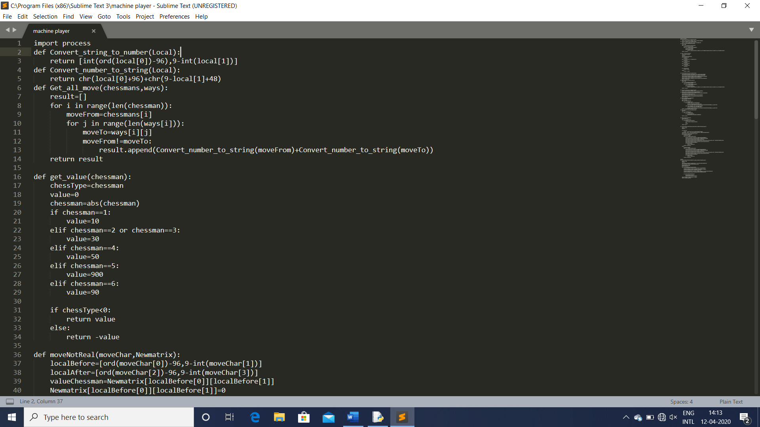

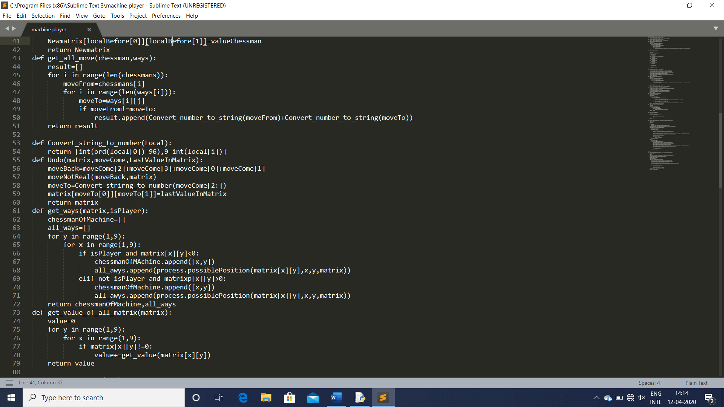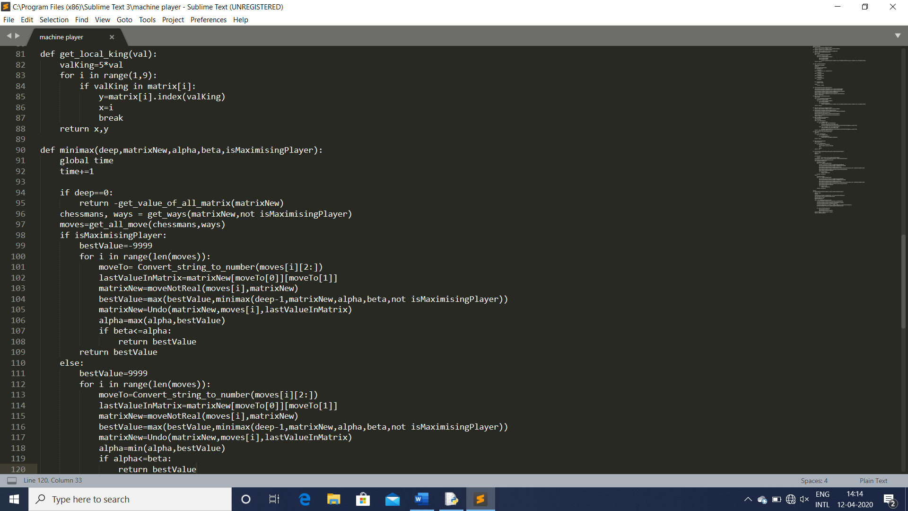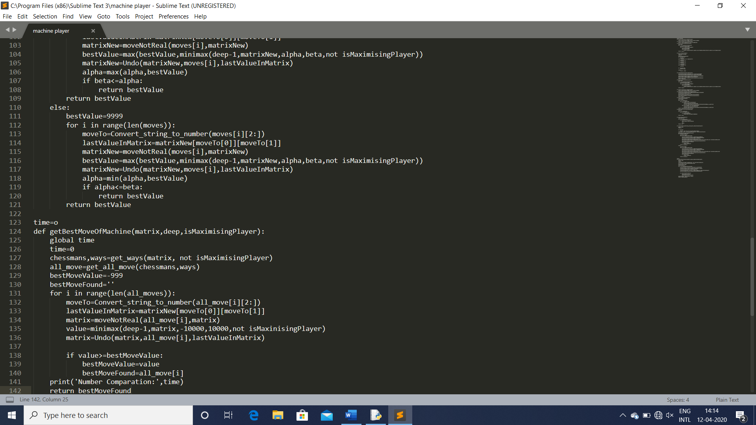

Code of Process:

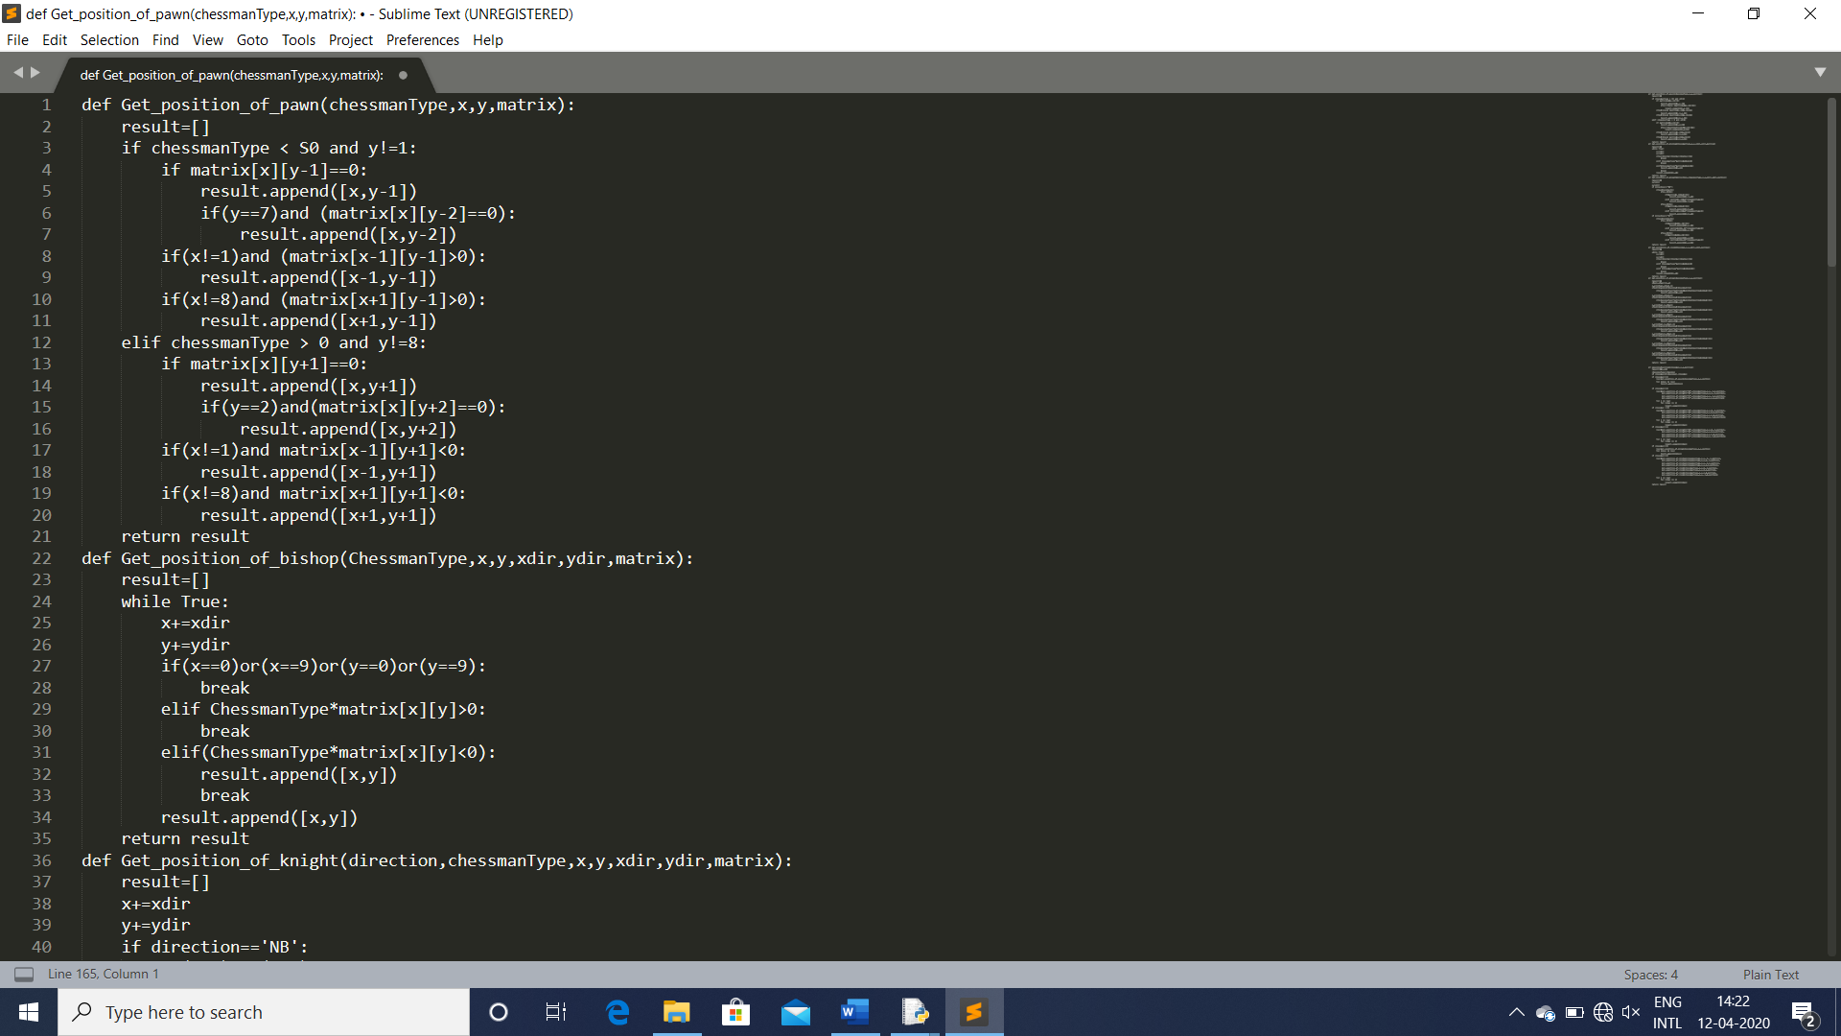

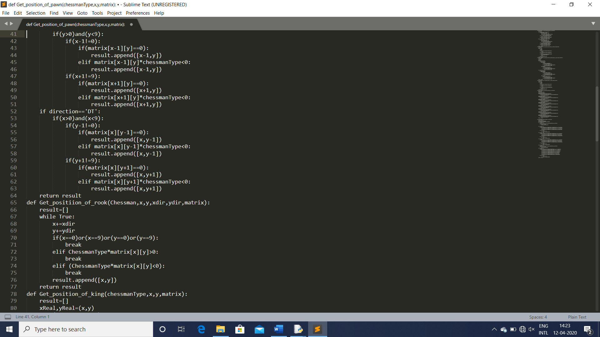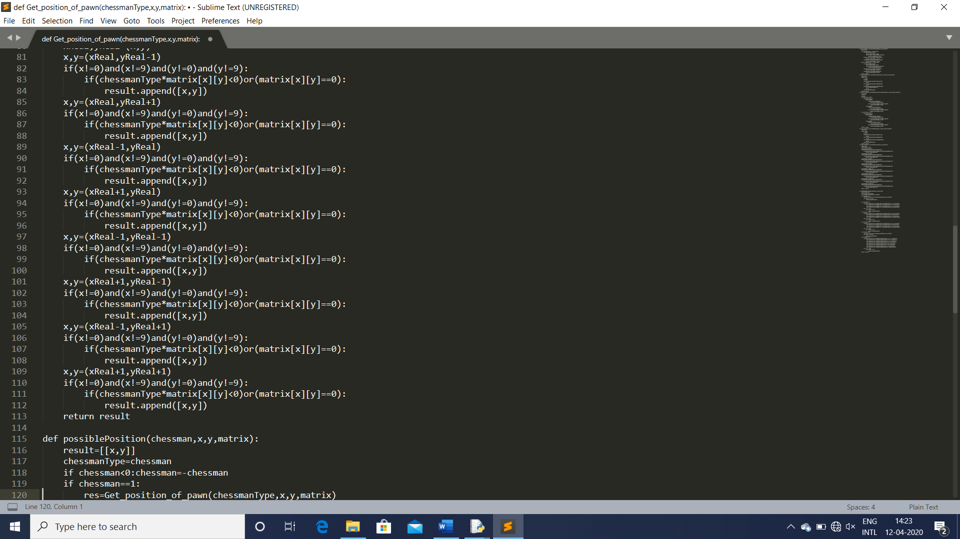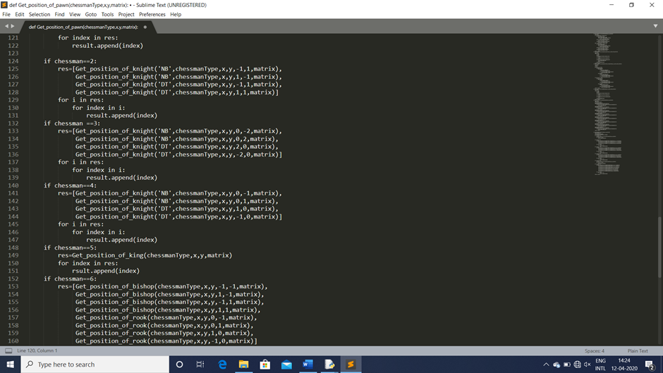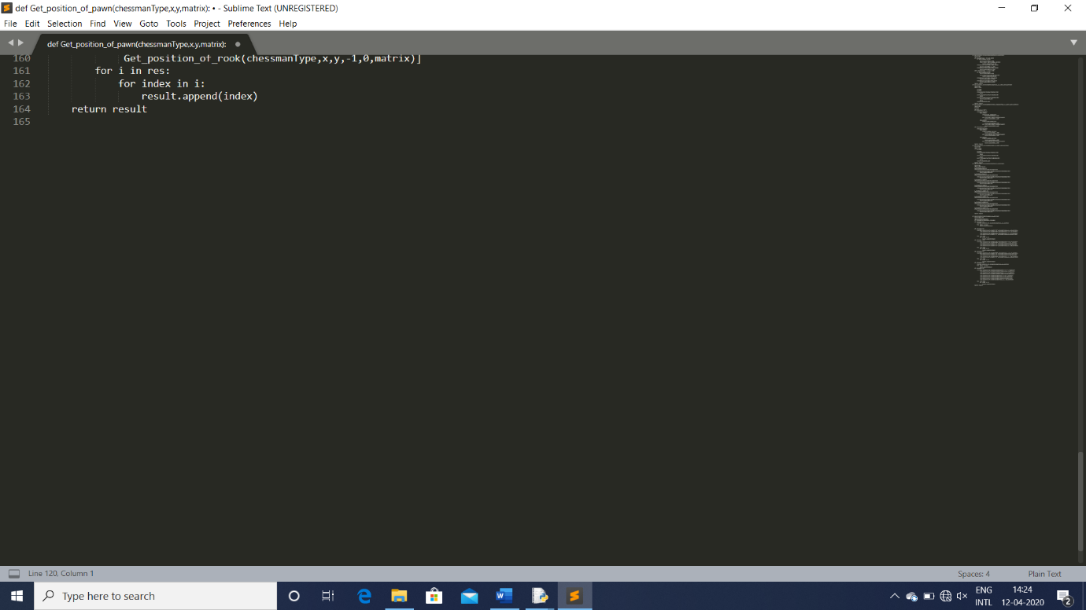

Code of AI chess game:-

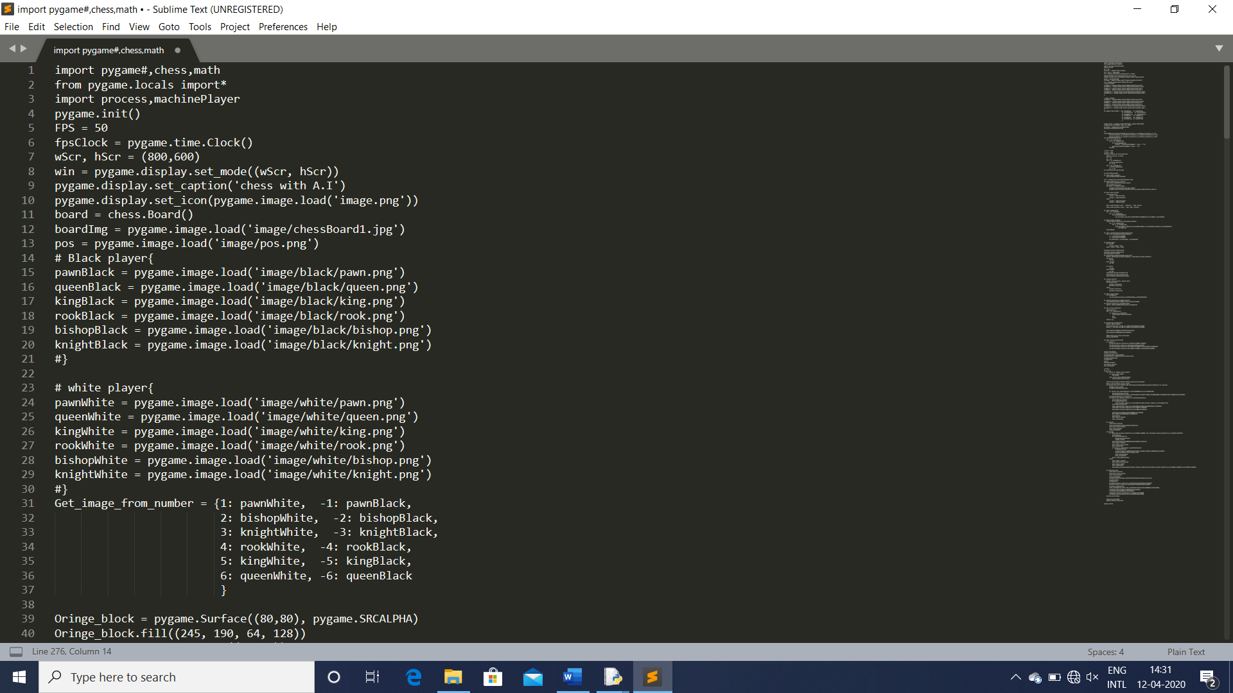

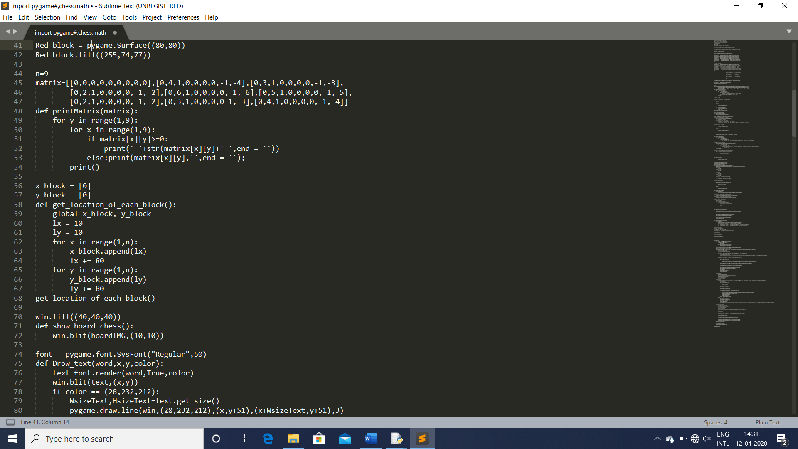

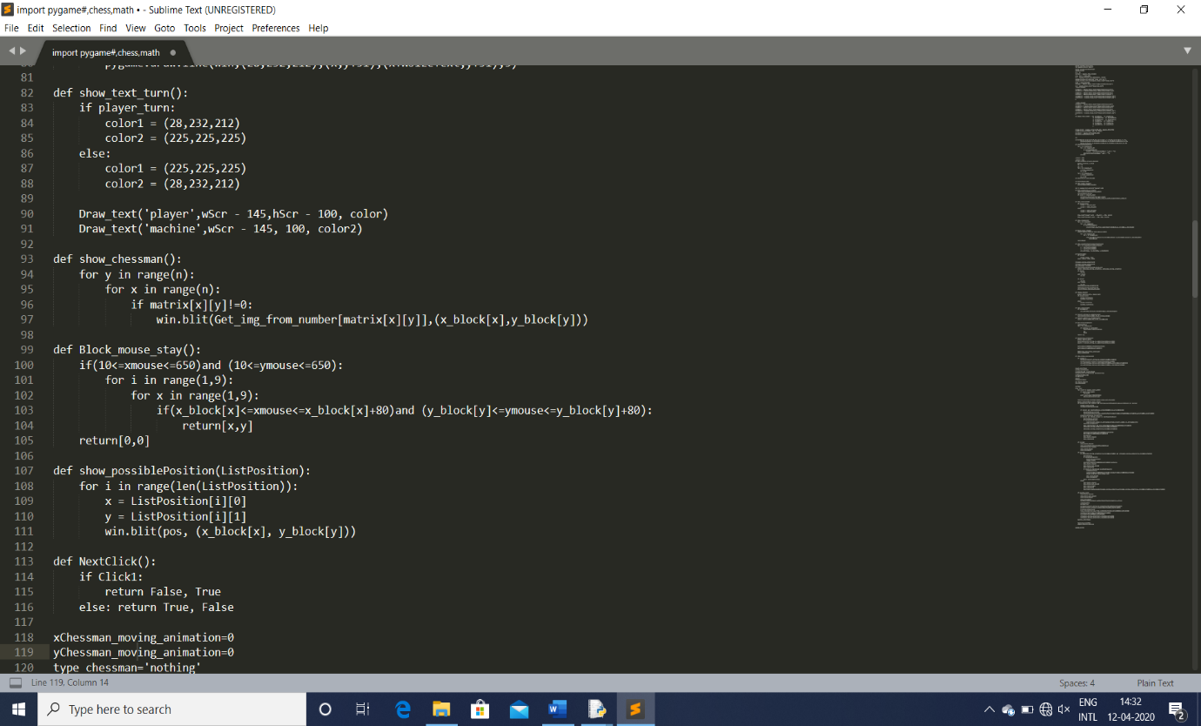

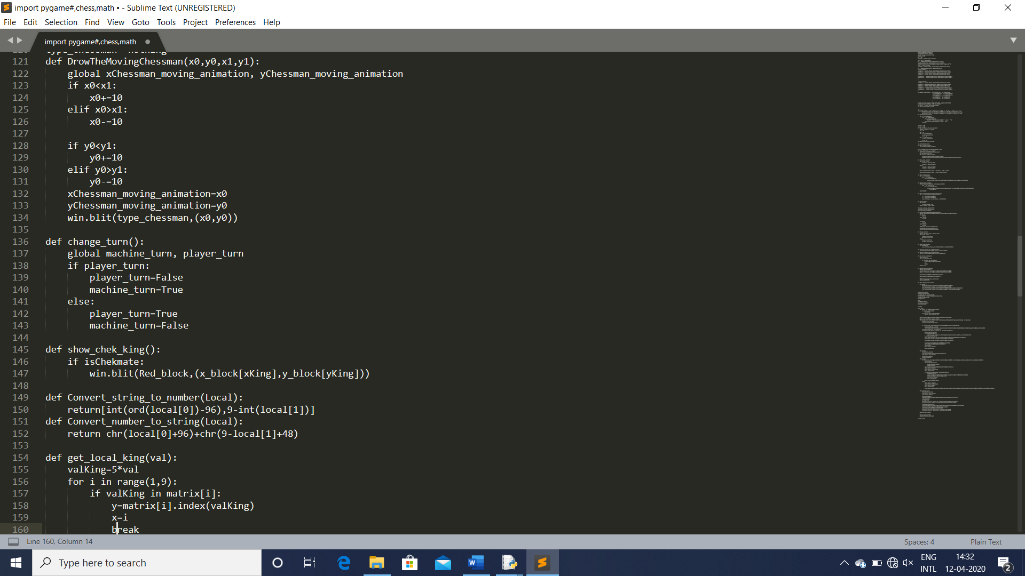

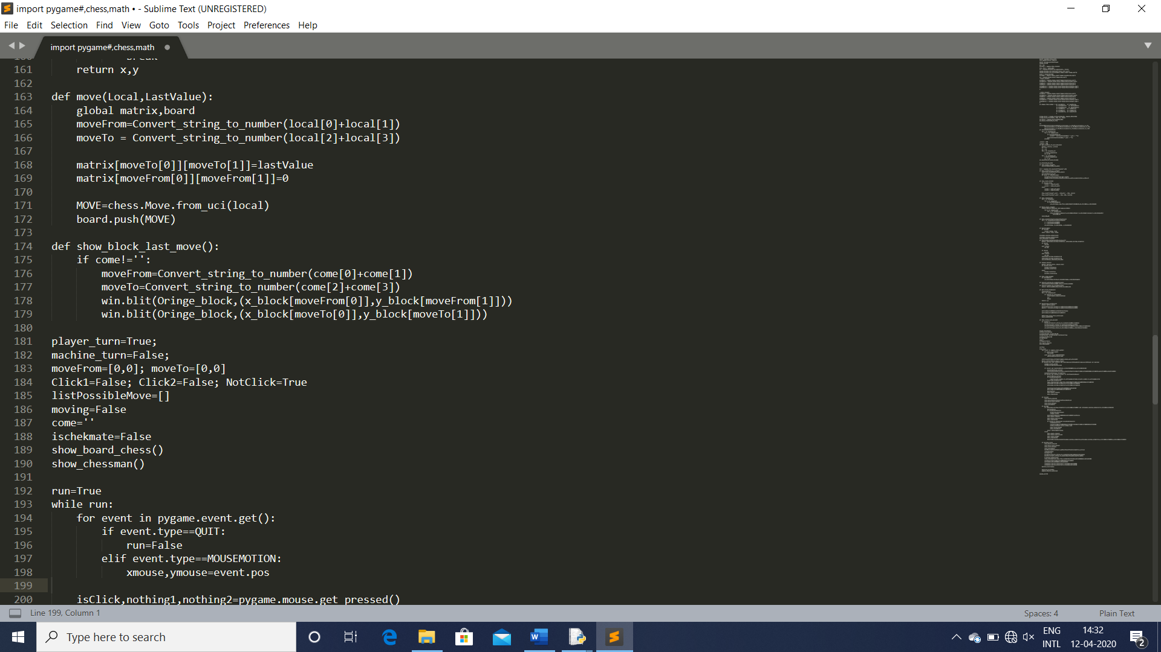

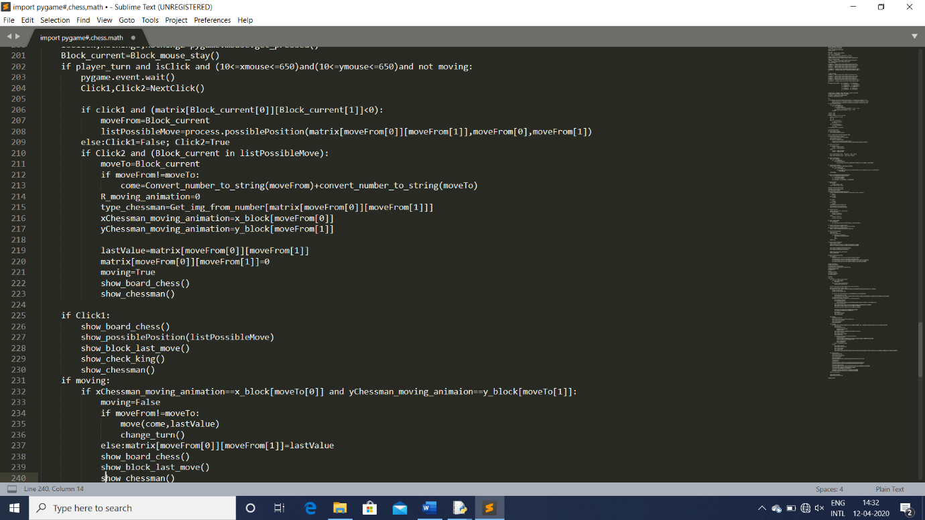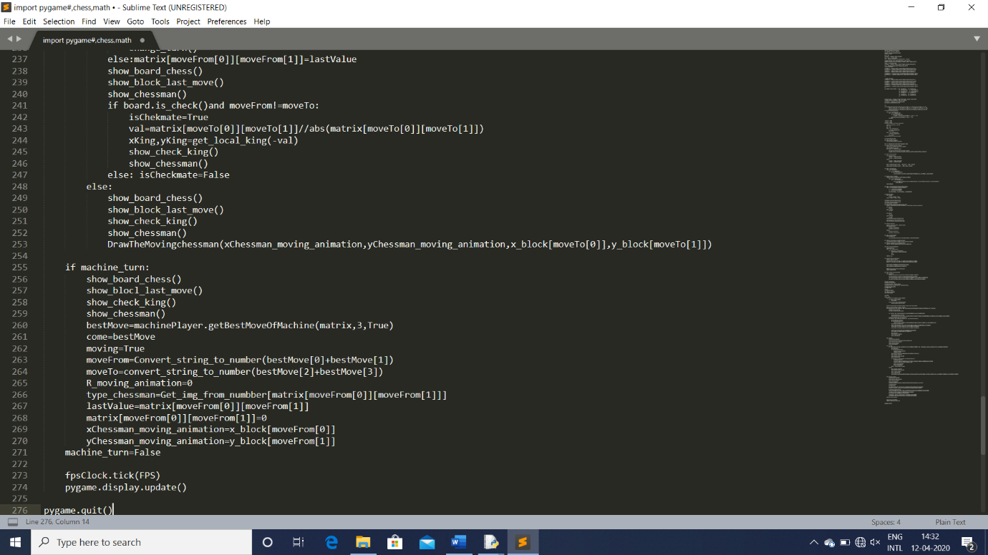

Working of project screenshots:-

Role of Group Member:-

K.Nagajyothi:- Help in Code of Process. Help in final Report.

Kajal Singh:- Prepare Synopsis and final Report. Prepare the machine player code.

Rahul Ranjan:- Prepare the code of process nd do the testing of the project.

Raushan Raj:- Create gantt chart,milestone and flow chart. Done the machine playercode.

Aman Kumar:- Prepare the AI chess game code.create the rules of the game. Done the testing of game.create the video link in google drive.

Technologies used in Project:-

Python

Sublime text

Google drive

Microsoft word

Video link:-

https://drive.google.com/file/d/1IZU1qhssdty16zBda8IyEAGago0RNjP1/view?usp=drivesdk

Thank You!!